Simulation for Business Analytics

Sarah Nolan - C19373926

Anna Walsh - C19318323

Jamie Mulrooney - C19403144

Jack Kennedy - C19376581

Philip O’Flynn - C19487582

Introduction:

In this report we will discuss the project that our group completed as we created a simulation model on ExtendSim for the business we were working with Bí Urban. Firstly, we will discuss the various stages of project that we had to do. These were split up into 5 phases: 1. Introduction and Preparation, 2. Data Collection, 3. Conceptual model, 4. Implementation and 5. If Scenarios and Design Testing. Next, we talked about recommendations for the business firm for system improvement. To finish each member of the group wrote a reflection piece about what they did and learned throughout the entire project and how they felt about it looking back.

Phases:

The first stage of the projected included getting to know our client, setting up meetings, and setting tasks for each team member. The client the team was working with is Bí Urban. Bí urban is a nature-based social enterprise, based in Stoneybatter in Dublin 7. Their mission is to promote health and well-being by connecting people, place, and nature. To get to know about the client and the firm, the team got together and organised a zoom meeting with the business owner Kaethe. The meeting was arranged via email and a date and time that suited everyone involved was decided on. Through the meeting, the team learned about the firm’s background and profile, business model and problem definition. During the meeting, the objective of the project was discussed and an aim to improve the supply chain was decided on. After the meeting, the tasks were broken down and distributed to the team members. This meant all team members were doing equal amounts of work and could focus on their individual tasks.

The second phase of the projected focused on gathering data. To do this the team manager set up a zoom meeting with the client via email. To prepare for the meeting the team got together to prepare questions that would get all the information needed. This list of questions was emailed to the client to ensure everyone was prepared for the meeting. The two-hour meeting focused on getting to know each other, the problem definition and gathering the data. The prepared questions made it easier to focus on the aspects on the firm's data that was needed and ensured nothing was forgotten. The main outcomes of the meeting were the stages of the soap making process, the people involved, the cost factors, ingredients and more. The problem definition was to improve the supply chain.

With this in mind, the team was able to begin the third phase of the project which was executing a conceptual model. All the information that each person noted was put together and compared to see what would be included in the model. It involved the steps and processes that the staff do in order to make soap that’s available for sale. It was decided that the conceptual model would be broken down into two sections, the first was the process of gathering ingredients and then taking these and creating the physical soap. The second section was taking the soap and packaging it or not, and finally it being delivered to the shop to be sold or delivered straight to the customer via a courier. The group worked together via zoom to put all these activities together and convert them into a conceptual model.

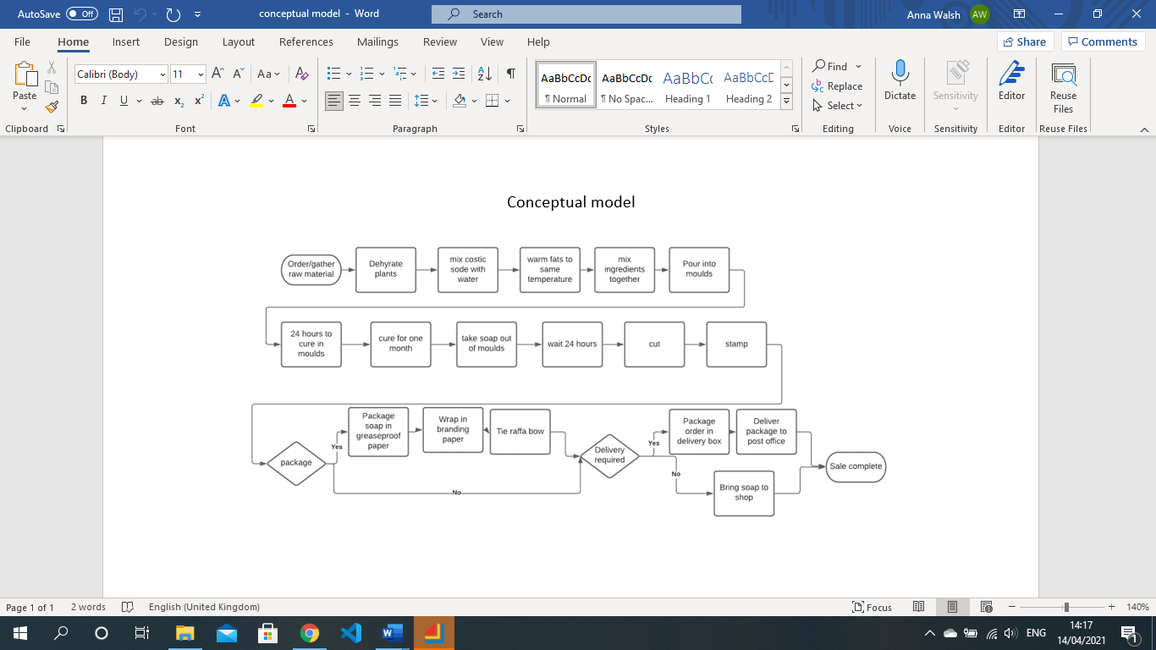After the conceptual model was created, it was used as a base to form an ExtendSim model. The fourth phase of the project was to create an ExtendSim model for Bí Urban. It was designed to illustrate the process of the soap from gathering ingredients to ultimately reaching the customer. The conceptual model was divided up in sections for each member of the group to make their own part of the Extendsim model. The sections included the gathering of ingredients, making the soap, packaging process and delivery process which were all in separate hierarchal blocks.

The first section took the ingredients as set out in a recipe of a Bí Urban soap that were collected and sourced locally. Aswell as that the staff members were included as another resource pool so they could be used in the model.

These were put through the soap making process which took the ingredients and passed them through the queues and activities of mixing, leaving the mixture to cure, taking the soap out of the moulds and finally leaving them to sit before cutting and stamping. The necessary staff and timings were also included. After these activities, the soap was batched and released back as a batch of soap which contained 70 bars so as it could be packaged and sold.

The bars of soap were then passed on to the packaging process. Bí Urban offer non-packaged and packaged products. The packaging process contains wrapping up the soap and tying it with a ribbon. The soap was taken and batched in to one order so as it could be sold to the customer.

As well, Bí Urban have two points of sale, online and in store. The soap can be delivered directly to the customer through AnPost or alternatively it can be bought directly in store which can be seen in the ExtendSim model below.

Scenario design and testing:

In this phase of the project, we had to come up with different scenarios in cooperation with Kaethe and then we had to solve these problems and make changes to our ExtendSim model to reflect the different scenarios. In the end we came up with three different scenarios that we had to test. They were, what would happen if the oil used in the making of the soap had to be substituted for another type of oil, what would happen if the season of spring had been delayed and finally what would happen if the oil used to make a batch of soap had not been properly filtered before being used in the process.

The first scenario we came up with, with the help of Kaethe, was what would happen if the wild flax oil used in the making of the soap was not available. In this scenario the wild flax oil would have to be replaced with olive oil in the soap making process. Using olive oil would reduce the quality of the soap and there would be a delay in the completion time of some batches of soap which could potentially lead to short-term loss of sales. To implement this in our ExtendSim model we had to simulate the delay from the realisation and changeover of the oils.

The second scenario that we came up with is what would happen to the process if the season of spring were late. This would mean that the flowers and plants that are essential to the soap that Bí Urban makes would not be available at the time when they would be most required and depending on how long spring is delayed by could have major or minor effects of the soap making process. These delays could also lead to loss in sales and profits and could delay the business by many weeks or it could only be delayed by a number of days. Similarly, too the first scenario when had to change the timings of the simulation to represent the delays to the entire process caused by spring being late.

The third and final scenario that we developed was what would happen if the oil used in a batch of soap was not properly filtered. This was a scenario that had happened before to the business, the oil that she bought had not been properly filtered which caused the soap to turn black in colour and began to oxidise. This ruined the batch of shop which both caused delays for the soap production and also cost her the price of the batch of soap and the loss of sales from the bad oil damaging the batch. To simulate this in ExtendSim we had to input delays into our model.

Recommendations for the business firm for system improvement:

As well as being a sustainable organization, we are aware that Bí Urban also does the best they can to help the environment. From using the waste of other companies to using composable labels, we know that any reasonable recommendations must take this into account. We are aware that Bí Urban sources certain materials from abroad to produce their products. We would suggest that Bí Urban sources all their ingredients from Ireland as this would improve the company’s carbon footprint which would greatly adhere to the company’s goal of being more environmentally friendly.

From a business point of view, we understand that sourcing 100% of the company’s raw materials locally can be difficult at times. This would suggest that we recommend that when the company feels the need to purchase materials from abroad, that they do so in bulk. Purchasing in bulk not only reduces the total amount of tax the company would have to pay, but it can also save time because the amount of time spent on sourcing materials would be reduced. We believe that this would make the company more time efficient.

We know that 100% of Bí Urban’s sales recently have been online sales due to the coronavirus pandemic. This means that the company has had to quickly adapt a delivery process which could be reliable for both the company and the consumer. We are aware that this would have been an inconvenience to the company as they would usually sell straight from their shop, however, this gives us another opportunity to identify more environmentally friendly ways to distribute their finished products. Our recommendation would be to attempt to greenify the company’s distribution network. If this delivery process in to stay in place after the pandemic, could the company manage its own delivery fleet? Perhaps the company could upgrade to electric or hybrid vehicles. The company could also choose to work with providers and suppliers with their own green initiatives. We believe that this could provide a link in a sustainability chain.

Project individual reflection:

Sarah Nolan -

As the team manager I had to lead the team through this project and with that I had many tasks to do. I was responsible for setting strategy and monitoring progress of the project. One of my first tasks as team manager was to contact the client and organise the first zoom meeting. To prepare for this I had a meeting with the team to prepare a list of questions that would gather all the information and data we needed. After the meeting and some researching, I had a clear idea of what had to be done. I wrote out a list of tasks and they were distributed amongst the team members. The first thing we had to work on was the conceptual model. We discussed the model as a team and then I worked on creating the conceptual model. The next part of the project to work on was the ExtendSim Model. I found this part challenging but after a few team zoom meetings we were able to break it down. Everyone was given a section of the ExtendSim to work on. I worked on the delivery section. When everyone had completed their task, I put it all together, made sure it ran smoothly and verified it with the team. Phase five was next and this included another meeting with the client. I organised this via email. The final part of the project was to do the written report and the PowerPoint. As usual I took the time to carefully break down and distribute the report tasks. As the leader I always wanted to ensure everyone was happy with their task and knew what to do. To do this I broke the report into individual tasks and organised a zoom meeting so the team could brainstorm ideas for each section and then choose which parts they wanted to do. I completed the first and second phase of the written report and overlooked and edited the final report.

This project was nothing like I had done before. In the beginning I felt overwhelmed as I was inundated with work, but after taking the time to carefully break down the tasks it became more manageable. I found the ExtendSim model the most difficult part of the project. It took a lot of research and time, but with hard work and cooperation, we were able to successfully complete it. I enjoyed working with my team and taking on the role of team manager. I learnt that I am good at leading a team and making sure everyone is included. I have improved my organisation skills by working around a schedule and deadlines. I this this project will be extremely beneficial in the future as I now have the experience of working with a client. I learned a lot about myself and what I am capable of, and I am proud of the final project.

Anna Walsh -

My main task in this project was making the ‘soap making process’ within the ExtendSim model. As ExtendSim was new to me, it took a while to learn all the different features and what to use where. I learnt that ExtendSim can be very useful for companies to visualize their own business and make improvements.

In the beginning we all met with Kaethe via zoom and discussed about her business. This gave me information about how they make soap. By working with BiUrban, I also got an insight into how a business interacts and engages with the community around them e.g. sourcing ingredients from local businesses.

I also was given the job to write about task three and task four in the report. These tasks covered the conceptual model and the ExtendSim model. We all worked together on both these tasks so it was fairly straight forward writing about these in the report. Within the report, I took screenshots of the Extendsim model to include in the report as I thought they would be of assistance in understanding the models.

Overall, I learnt a lot about the ExtendSim software and how it can be used. I also learnt about working with an external person. It is sometimes more difficult as it was not face to face and we had to email Kaethe if there were any questions which took longer to get replies.

In general, I think the group worked well together even though it was all via zoom. Sometimes it was hard to get a time that we could all meet as people were busy or working at different times. Over the duration of the project, we all kept in contact with each other on a regular basis which made it easier to complete the various sections and tasks for each deadline.

Jamie Mulrooney -

Working with Bí Urban has made me realise the struggles that all small businesses have encountered during the coronavirus pandemic. Identifying ideas to help the company has been difficult, however it shows how difficult running a business can be. This is the first time I have worked alongside a company and not just for a company as an employee. It has strengthened my communication skills as we have had to independently collaborate with the company ourselves trying to solve problems and identify where we have gone wrong and where we can improve our ExtendSim model. Communication with the company was important but also the communication within our team was essential. Having good relations with the other team members has helped with our management of the project in terms of assigning different roles to different people. I was assigned to produce the teams’ recommendations to the company we were working with. This involved team meetings where we would identify aspects of the business where we think could be enhanced. This was not easy as it involved a lot of collaboration and researching of the company.

I was also involved in the creating of our ExtendSim model. I used my previous knowledge from past lectures to create my part of the model. I was assigned the ‘collecting of ingredients’ aspect of the model. This is the first part of our model, so it was important to get it right. This involved having to know where the company sourced each ingredient they used. From there, I navigated the websites where they sourced ingredients from in order to work out how much the company spends on ingredients to produce one batch of soap. This information was then fitted into the model which gave of accurate results. Reflecting on the project, I believe we worked well as a team. We set targets and were able to meet them consistently. We communicated well with each other and the company.

Jack Kennedy -

In the project I was tasked with working on the packaging and delivery stage of the ExtendSim model, as well as writing the scenario design and testing and the if scenario design and testing part of the final report. The packaging and delivery stage of the ExtendSim model consisted of two parts, the packaging of the soap stage and was followed by the delivery of the soap to either the shop or to the post office, where the soap would then be delivered to the customers. In the report for the project, I had to write the scenario design and testing and the if scenario design and testing parts of the final report, this part was about the what if scenarios we had to come up with after the final meeting, we had with Kaethe. After the meeting we came up with three what if scenarios and tested each of them in the ExtendSim model. From this project I learned a great deal about ExtendSim and how to use it to make detailed simulations for business both large and small business in many fields. This project also taught me a lot about how small business run and how they are managed. We got an insight into the workings of Kaethe’s Bí Urban soap company which allowed us to see the finer or smaller parts of the company that cannot be seen from the outside. Both of these will be very important and impactful learning experiences and two which I can hope will benefit me later in both my academic and working life.

Philip O’Flynn -

Throughout this year I thoroughly enjoyed working on this project from the get-go. At the beginning when I was first learning about ExtendSim I struggled to grasp the idea and was worried I would fall behind. But like most new modules in college every class I was learning and getting more comfortable with the software. When I learned that, as a class, we were going to be working with a business for our group project I was delighted as it gave a great opportunity to implement the new skills that I had learned in a real-life scenario. Unlike most modules I was able to experience what it was like working with a business in the real world rather than just writing up on a random company that I did not know much about. This was what really got me engaged with the module and project. When working with Bí Urban it was interesting to see all the small details that go into running a business and it was great the able to communicate with Kaethe and her colleagues.

When it came to the ExtendSim I worked on the latter parts of the model and also with the delivery section. I put everyone’s individual sections, the ingredients, soap making, packaging and delivery process into separate hierarchal blocks. For the final part of the project, I took charge of doing the presentation along with the introduction and conclusion of the written report. I volunteered to do the presentation as I enjoy working with PowerPoint and have made them previously with numerous modules this year.

Working with a group for this project was very enjoyable and we worked really well together as we were able to designate parts of the project to different people. Between working with my classmates and working with Bí Urban I felt that I learned a lot and improved my communication and group work to new level. All in all, it was a wonderful experience, and I am really proud of the work my classmates and I did.

Conclusion:

In conclusion, a conceptual model and an ExtendSim model was constructed for the company Bí Urban. The activities and process that Kaethe and the team go through in order to gather ingredients, make the soap mix, package the individual bars and finally the delivery of the products is shown in these models. Different scenarios were trialed and tested based upon ‘what if’ scenarios were to happen in the company and how they could be managed. Recommendations were also given to Bí Urban on how they could tweak and change their model in order to improve the supply chain. Recommendations were also given to Bí Urban to help them achieve their own goal of becoming a completely green and environmentally friendly company.

Declaration:

We declare that this material, which we now submit for assessment, is entirely our own work and has not been taken from the work of others. We understand that plagiarism, collusion, and copying are serious offences in TU Dublin and accept the penalties that would be imposed should we engage in plagiarism, collusion or copying. We have read and understood the Assignment Regulations. This assignment, or any part of it, has not been previously submitted by us or any other person for assessment on this or any other course of study.

Sarah Nolan, Anna Walsh, Jamie Mulrooney, Jack Kennedy, Philip O’Flynn

Date: 28/04/2021